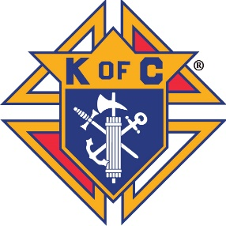 **Knights of Columbus**

**Kentucky State Charities**

**What we do for ourselves dies with us.**

**What we do for others and the world remains and is immortal. – Albert Pine**

Gabriel Cabral

**REQUEST FOR FUNDS**

Individual or Organization Requesting Funds Amount Requested

Name of Individual Submitting Request

Address City, State, Zip

Phone Number & Email

Description of Request:

Use back of form if more space is needed

Signature Date



Send To:

Gabriel Cabral

KY State Charities Chairman

261 Evergreen Court

Bowling Green, KY 42104

Chairman

261 Evergreen Ct

Bowling Green, KY 42104

psdgabe@gmail.com

Cameron Peck

Secretary

796 Wellington Way

Lexington, KY 40503

cameronpeck@gmail.com

Dannie Harris

Treasurer

654 Morrison Road

Big Clifty, KY 42712

kofckycharities@gmail.com