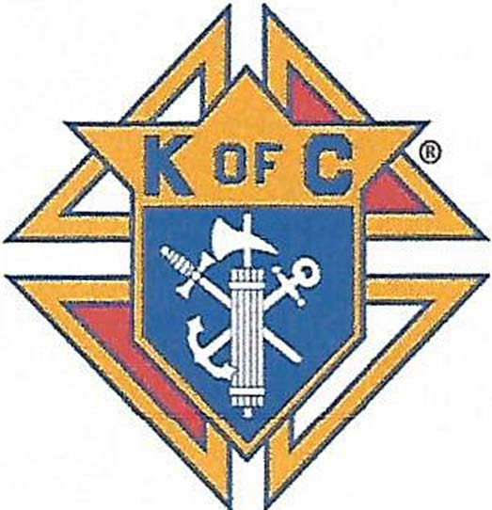

GRANT APPLICATION
Knights of Columbus
Kentucky Association for Persons
with Intellectual Disabilities

P.O. Box 206067, Louisville, KY 40250-6067

Name of Applicant Organization

Name of Person Submitting Request Date

Address Telephone

Is Applicant a 50l{c)3 Organization?

__Yes

___No

Amount of Funds Requested $_________________

Amount of Needed to Fully Fund Project $_______

Will Funds be used as Matching Funds $_____________

Grant Requirements
- Deadline for Submission of Grant is October 1st
- Copy of Organization's 501 (c)3 non-profit status
- Grant must be for a specific project or program
- Provide letter describing the project or program and how it benefits persons with Intellectual Disabilities
- Grant cannot be for a Capital Campaign
- Latest Form 990
- Copy of Budget for project or program where fund are to be used
- Funds will be distributed the following February
Mail Grant Requests to: Tom Johnson P.O. Box 206067, Louisville, KY 40250-6067

